USER GUIDE

This help guides you through the core features of the Auto Parts Store Management application: a Windows desktop solution designed to streamline your shop’s operations by digitizing inventory control, sales processing, and user account management.

What the App Does
- Inventory Management: Add new parts, restock existing items, and update pricing.
- Sales Processing: Sell parts quickly and accurately, with real-time stock updates.
- User & Role Management: Secure, role-based access for Administrators, Stock Managers, and Sales Clerks.

Who Should Read This
This help is organized into three chapters, each tailored to your role and permissions:
- Admin’s Guide: Full control over user accounts.
- Stockman’s Guide: Manage product catalog, stock levels, and pricing.
- Seller’s Guide: Process sales and view current inventory.

All three guides begin with the same essential step: logging into the system (fig 1). Before an Administrator, Stock Manager, or Sales Clerk can access their respective dashboards—whether to manage user accounts, update inventory, or process sales—all users must first authenticate themselves. Below is an overview of how to log in.
LOGGING IN:
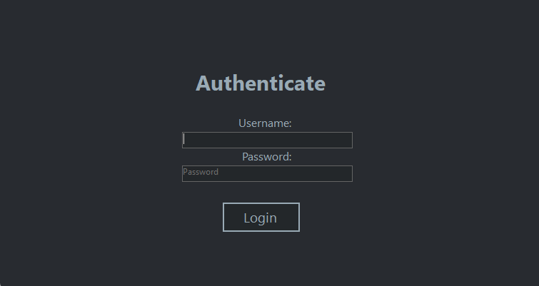
Fig 1. Log in screen
Firstly, you must type in your username into the first (1) textbox and the password into the second (2) textbox. After you have typed them, you press the Login (3) button -> Fig 1.1
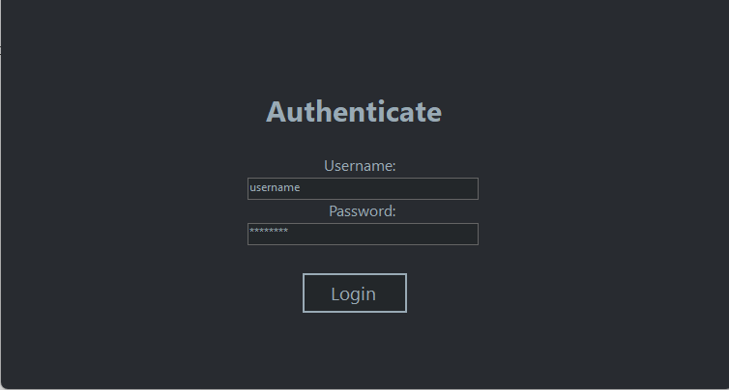
3
1
2
Fig 1.1 Log in tutorial

If the password or the usernames were incorrectly typed, you will get the following pop-up (Fig 1.2). Do not panic! Press the OK (1) button and try again. If you continue on getting errors, contact the administrator of the service.
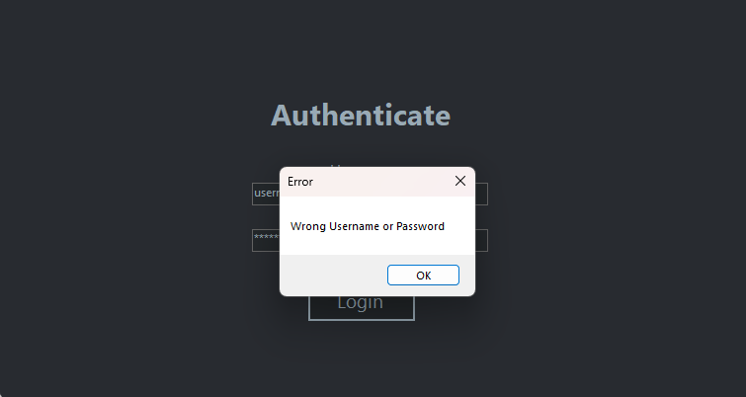
1
Fig 1.2 Log in failed screen

- Administrator Guide
Welcome to the guide dedicated to the Administrator role! Here you’ll find everything you need to manage the users of the application.
Prerequisites
- You must be logged in with an Administrator account.
Contents
- Adding a new user
- Viewing & Refreshing the User List
- Deleting a User
- Updating an user's password
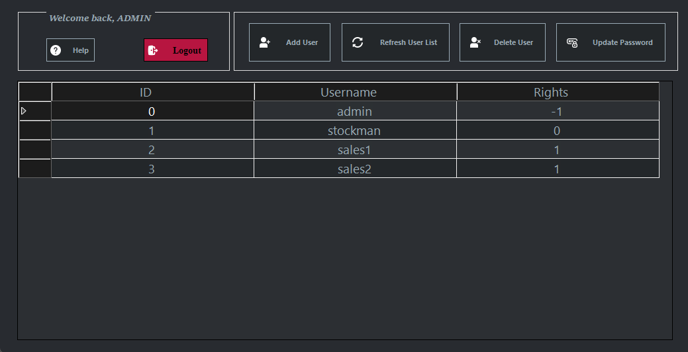
7
6
5
4
3
1
2
Fig 2. Administrator dashboard
Figure 2 explained:
- Help button: Opens the help menu
- Logout button: You log out from your account
- Opens the add an user button
- Refreshes the user list (7)
- Delets an user
- Updates and user’s password
- Shows the user list

  - Adding a new user
Press the Button number 3 from Fig 2. Afterwards, you will see the following pop-up (fig 2.1):
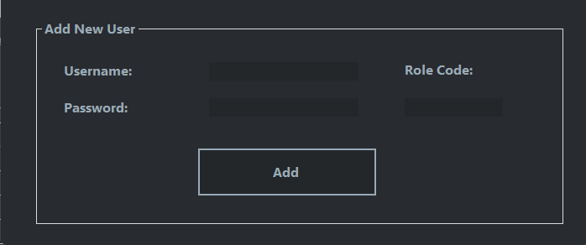
4
3
2
1
Fig 2.1
In order to add a new user, complete the form as follows:
a) Username (1) – a unique identifier (required)
b) Password (2) - temporary password for the new account (required)
c) Role Code (3), as follows:
i) 0 for a Stock Manager
ii) 1 for a Sales Clerk
d) Click the Add (4) button.
e) If the input is valid, you’ll see a confirmation:
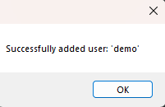

f) Back on the Menu, click Refresh User List ( Fig 2 button 6) to confirm the user has been added.

Possible errors:
1. Empty Username or Password
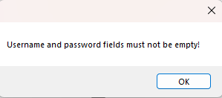

When you see this, you know you must type in the username and the password for the process of registering a user to be completed.
2. Invalid Role Code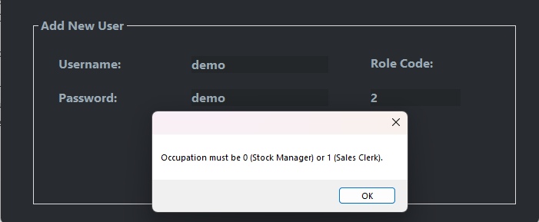
When you see this pop-up, you know you have to add valid Role Codes.
- Same username as an existing account: The username must be unique
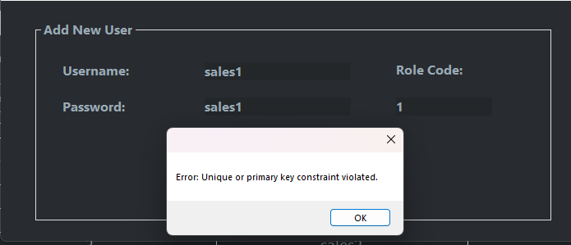

1.2 Updating an user’s password
- From the Menu toolbar, click the Update Password button (6 Fig 2), then the following popup will appear:
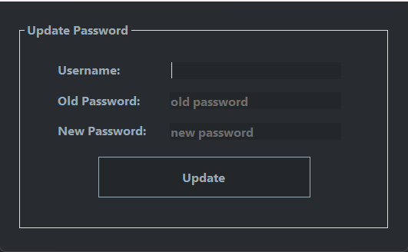
4
3
2
1
- In the Update Password dialog, complete all fields:
  - Username (1) – the user’s unique identifier (required)
  - Old Password (2) – the user’s current password (required)
  - New Password (3) – the password you want to assign (required)
- Click UPDATE (4).
- If the input is valid, a confirmation message appears:
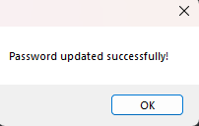
- The dialog closes automatically.

Validation & Error Messages

- Any Field Left Blank
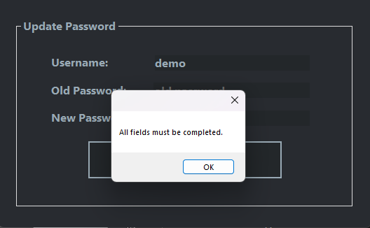
- Invalid username (non-existent)
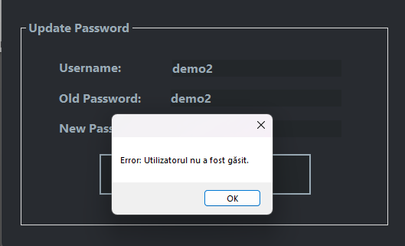

After each of those errors, Consider the pop-up message and fix the problem.

1.3 Deleting an user
- From the Menu toolbar, click the Delete User button (Fig 2 button 5), then the following pop-up will appear:
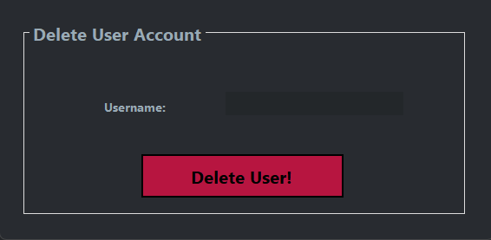
1
2
- In the Delete User dialog:
  - Enter the Username (1) of the account you wish to delete (required).
- Click Delete (2).
- If the input is valid, a confirmation message appears:
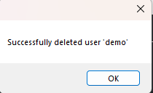
- The dialog closes automatically.
- Back on the Menu, click Refresh User List to confirm the user has been removed.

Validation & Error Messages

- Empty Username Field
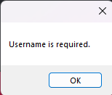
- User not found
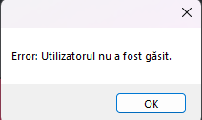

    - Stockman's Guide
Welcome to the Stockman's Guide! Here you’ll find all you need to manage inventory:
- adding new parts, restocking existing items, updating prices, selling and keeping your product list up to date.
Prerequisites
- You must be logged in with a Stockman account.
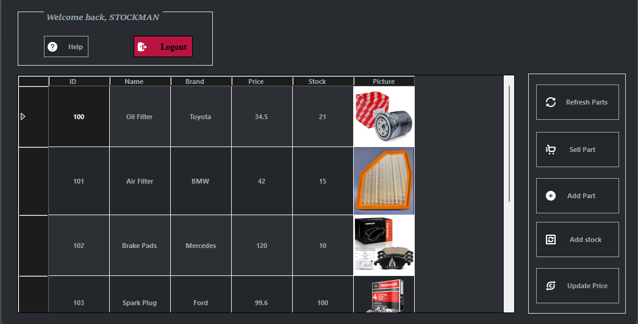
Stockman’s menu:
8

7
6
5

4
3
2
1
Fig.3.
Explaining of the buttons:
  - Opens the help menu
  - Logout button
  - Refreshes the part list
  - Sell a part
  - Add a part
  - Add to the stock of a part
  - Update the price of a part

2.1. Adding a new Part
Allows a Stock Manager to create a new auto part record in the system, specifying its brand, model, barcode, price, and initial stock.
Steps to Follow
- On the Menu toolbar, click Add New Part (Fig 3. Button 5)
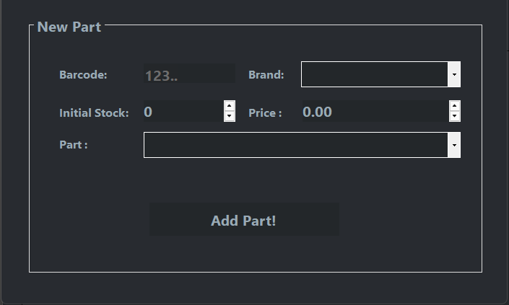
6
5
4
3
2
1
- In the New Part dialog, complete all fields:
  - Brand (2) – select a valid manufacturer from the dropdown (required).
  - Part (5) – once a brand is selected, choose a model from the Part dropdown (required).
  - Barcode (1) – enter the part’s numeric code (required).
  - Price (4) – set the unit price (must be > 0).
  - Initial Stock (3) – set the starting quantity (must be ≥ 0).
- Click Add (6).
- If the input is valid, a confirmation message appears:
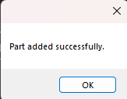
- The dialog closes automatically.
- Back on the Menu, click Refresh part List ( Fig3 button 3) to view your new part.
Validation & Error Messages

- Invalid Brand Selection
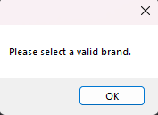
- Invalid Part Selection
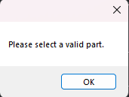
- Barcode Not a Number
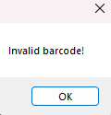
- Price ≤ 0 or Stock < 0
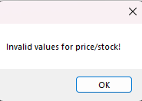
Follow the message from the errors to solve them.

2.2. Adding to the stock
Allows an Stock Manager to increase the inventory count for an existing auto part by specifying its barcode and the quantity received.
Steps to Follow
1.On the Menu toolbar, click Add to Stock (5), then the following pop-up will appear:
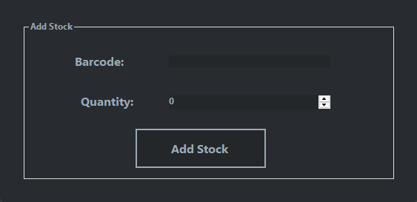
3
1
2
2.In the Add Stock form, complete:
1. Barcode(1) – enter the part’s numeric code (required).
2. Quantity(2) – enter the number of units to add (must be greater than 0).
3.Click Add to Stock(3).
4.If the input is valid, a confirmation message appears:
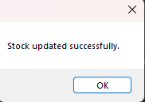
5.The dialog closes automatically.
6.Back on the Menu, click Refresh Product List (Fig3 button 3) to view your new part.

Validation & Error Messages
- Invalid Barcode
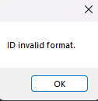
- Invalid Quantity
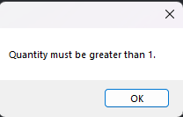
- Unknown product:
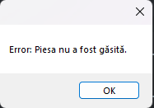

In order to fix the errors, you have to read them and try to resolve the problem displayed in it.
2.3. Updating a part’s price
Allows a Stock Manager to change the unit price of an existing auto part.

Steps to Follow
1.On the Menu toolbar, click Update Price ( Fig 3 button 3), then the following pop-up will appear:
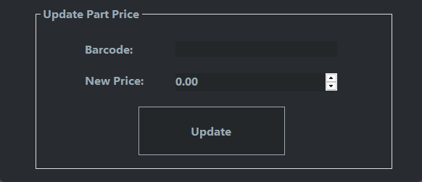
3
2
1

2.In the Update Part Price dialog, complete:
1. Barcode (1) – enter the part’s numeric ID (required).
2. New Price (2) – enter the updated unit price (must be > 0).
3.Click Update (3).
4.If the input is valid, a confirmation message appears:
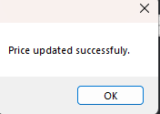
5.The dialog closes automatically.
6.Back on the Menu, click Refresh Parts (Fig 3 Button 3) to see the new price in the product list.
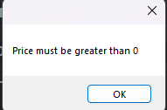
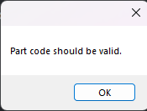
Validation & Error Messages
- Invalid Barcode Format

- New Price ≤ 0

In order to fix the errors, you have to read them and try to resolve the problem displayed in it.

    - Sales Clerk + Stockman: Selling a part
As a stockman, press the Fig 3 button 4 in order to initiate a transaction.
As a sales Clerk, in order to initiate a transaction, you will need to:
- Log in, as displayed in the beginning
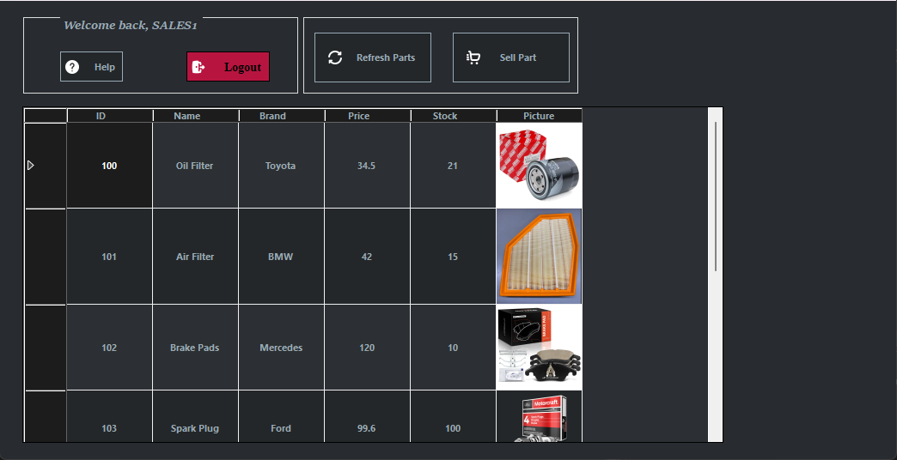
- Then, you will see the following panel:
5
4
3
2
1
Figure 4.
  - Help button: Opens the help button
  - Logout: Logout from the current account
  - Refresh Parts: refreshes the part list, after a sale
  - Sell Part: Sells a part
  - Part List
3.1. Selling a part
As a Stockman, press the button 4 from figure 3. As a Sales Clerk, press the button 4 from figure 4.
Steps to Follow
  - On the Menu toolbar, click Sell Part, as explained in the section from above, then the following pop-up will appear:
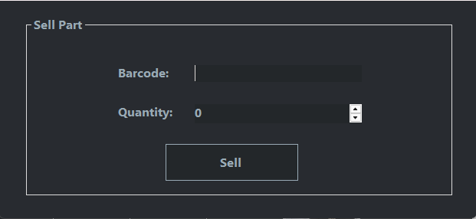
3
2
1
2. In the Sell Part dialog, complete all fields:
1. Barcode(1) –enter the part’s numeric code (required).
2. Quantity(2) - enter the number of units to sell (must be ≥ 1).
3. Click Sell(3).
4. If the input is valid, a confirmation message appears:
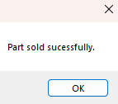
5. The dialog closes automatically.
6. Back on the Menu, click Refresh Product List(Fig 3 button 3 for Stockman, Fig 4 button 3 for Sales Clerk) to view your new part.
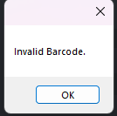
Validation & Error Messages

• Invalid Barcode

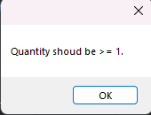
• Quantity < 1
In order to fix the errors, you have to read them and try to resolve the problem displayed in it.

Thank you for choosing our Auto Parts Management app!

For any other questions, feel free to ask the developing team for technical support and analysis.

